Portfolio 3

*Part I - Simulating data*

*Use the meta-analysis reported in Parola et al (2020), create a simulated dataset with 100 matched pairs of schizophrenia and controls, each participant producing 10 repeated measures (10 trials with their speech recorded). for each of these "recordings" (data points) produce 10 acoustic measures: 6 from the meta-analysis, 4 with just random noise. Do the same for a baseline dataset including only 10 noise variables.*

In this assignment we’re interested in assessing vocal markers of Schizophrenia to test if these can help classify patients with Schizophrenia over healthy control. To do this we apply a Machine learning pipeline first to simulated data and next to our empirical data. The machine learning pipeline consists of:

* Data budgeting: we set aside a balanced test set for the last validation of the model that is representative of the population.
* Data preprocessing: we scale the predictors, so all features are on the same scale.
* Model fitting: we fit our training data to our defined formulas
* Performance: we assess the model’s performance on the test set

In this first part, we base our analysis on the results from the Meta-analysis from Parola et al (2020). We create an informed simulation and a skeptical simulation to have a comparable baseline that can test the robustness of the Model. The informed dataset is based on the effect sizes from Parola et al (2020), with the following effects: 0.25, -0.55, -0.75, -1.26, 0.05, 1.89, plus 4 with just random noise (0, 0, 0, 0).

The two data frames consist of 100 matched pairs of Schizophrenia and Control with 10 repeated measures per participant and 10 measures of their speech with different focus: Pitch mode, Pitch variance, Speech rate, Amount of time spoken, The number of pauses, The length of the pauses and four with just noise. This gives us two 2000 x 13 data frames with the following variables: “Group", "ID", Trial”, ”noise1" , "noise2", "noise3" , "noise4", "Pause_length", "Pause_number", "Pitch_mode", "Pitch_vari" , "Speech_rate" and "Spoken_time" .

We extend our ML pipeline to include data simulations as simulated data can be used in a machine learning pipeline to test the feasibility of a proposed model or to compare the performance of different models. In both cases, the simulated data can help us to identify potential issues with our models and can be used to determine which model is best suited for the task at hand.

The simulations are visualized in the following plots, where you can quickly uncover some differences between the two groups in the informed dataset:

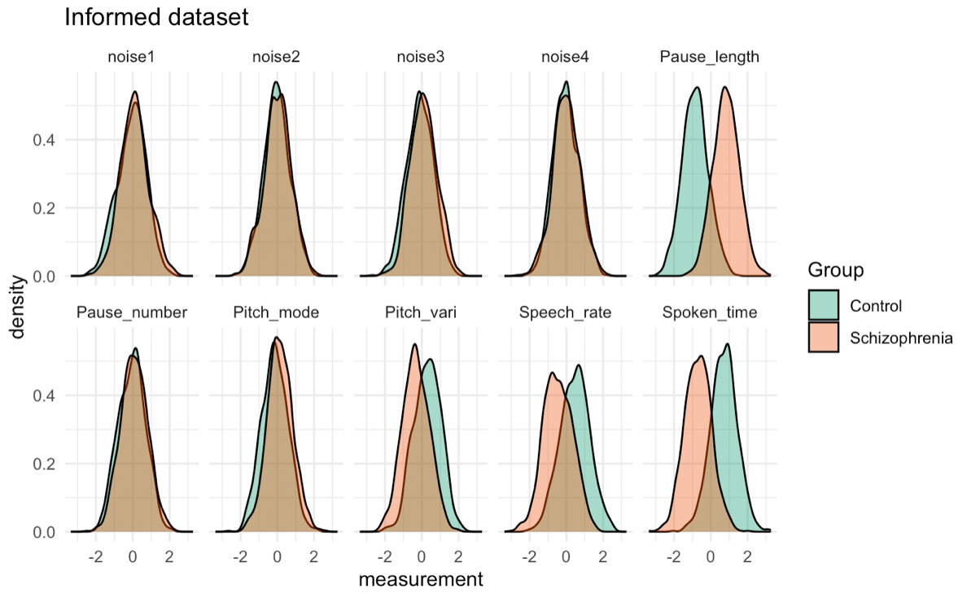

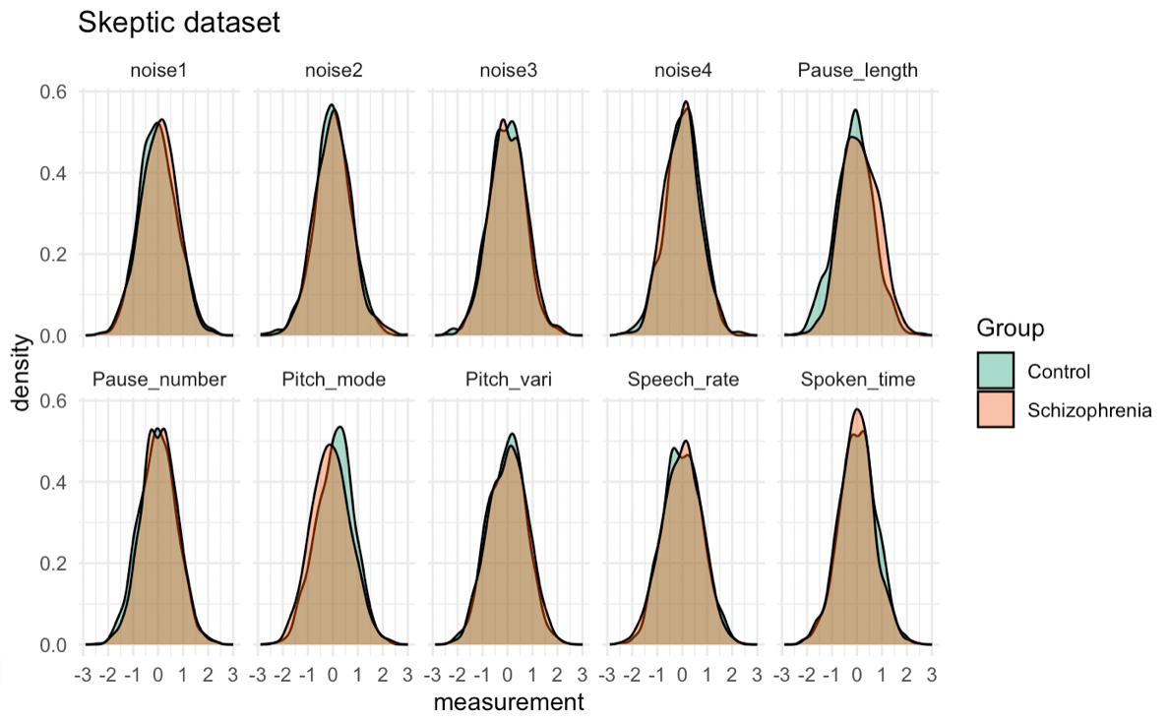

*Part II - ML pipeline on simulated data*

Now we move on to applying our pipeline to the simulated data. We make a balanced training and test set for the two data sets, with 20% of the participant in the test set and the rest in the training set. This leaves us with two 400 x 13 tibbles for test and two 1600 x 13 tibbles for training that we then scaled to make it easier to work with.

We define 3 different models for our pipeline:

1. ***Model with fixed effects:***

*PitchRange_f0 <- bf(Group ~ 1 + Pitch_mode + Pitch_vari + Speech_rate + Spoken_time + Pause_number + Pause_length + noise1 + noise2 + noise3 + noise4)*

1. ***Model with varying intercepts.***

*PitchRange_f1 <- bf(Group ~ 1 + Pitch_mode + Pitch_vari + Speech_rate + Spoken_time + Pause_number + Pause_length + noise1 + noise2 + noise3 + noise4 + (1|ID))*

1. ***Model with varying slopes:***

*PitchRange_f2 <- bf(Group ~ 1 + Pitch_mode + Pitch_vari + Speech_rate + Spoken_time + Pause_number + Pause_length + noise1 + noise2 + noise3 + noise4 + (1 + Pitch_mode + Pitch_vari + Speech_rate + Spoken_time + Pause_number + Pause_length + noise1 + noise2 + noise3 + noise4 | ID))*

For all 3 models we define some very loose priors since we don’t want the priors to be constraining the models as that can give worse accuracy when you have data with signal.

Prior predictive check:

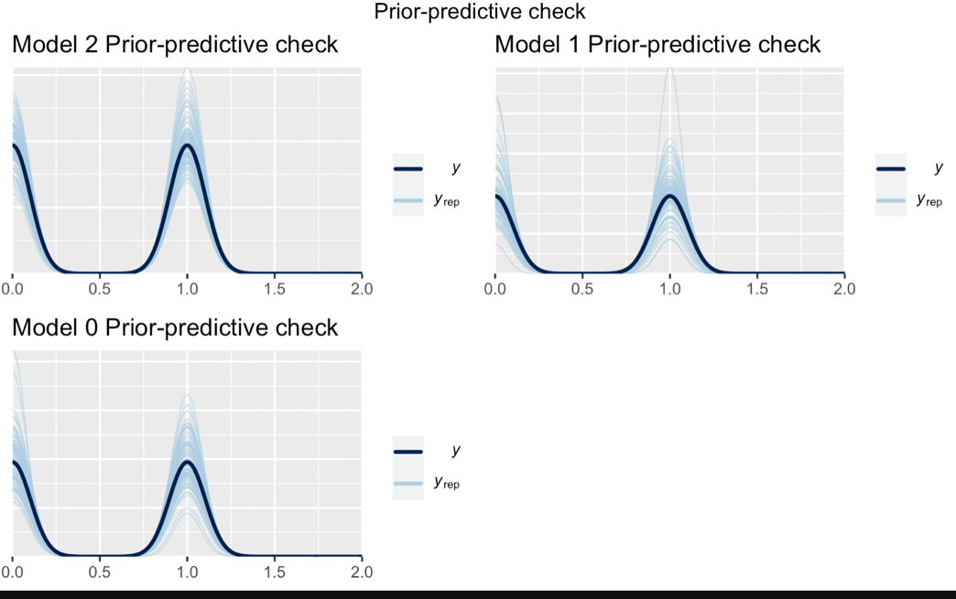

The priors all look good.

We then fit the models and perform some posterior-predictive checks:

Informed data: posterior predictive check

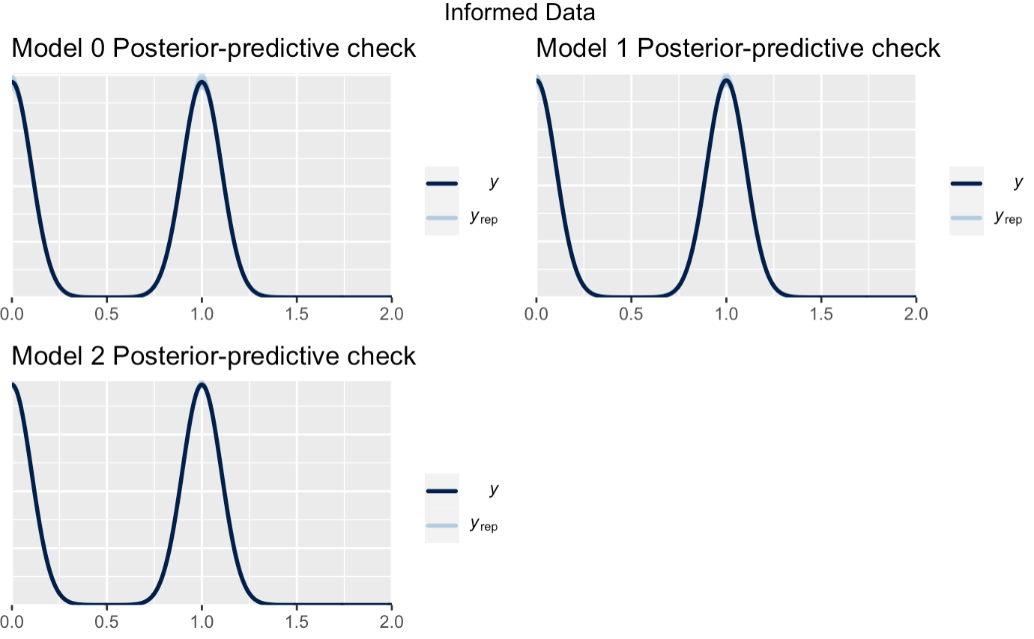

Skeptic data: posterior predictive check

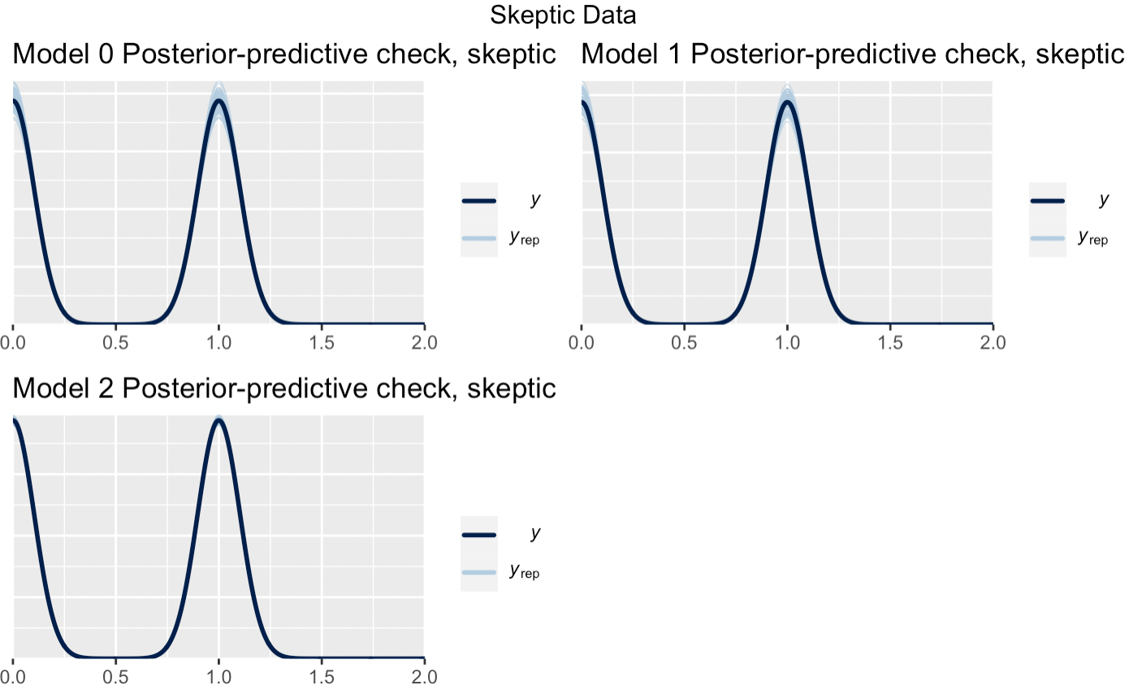

For both data sets it looks very sensible.

Update plots:

Fixed effects model:

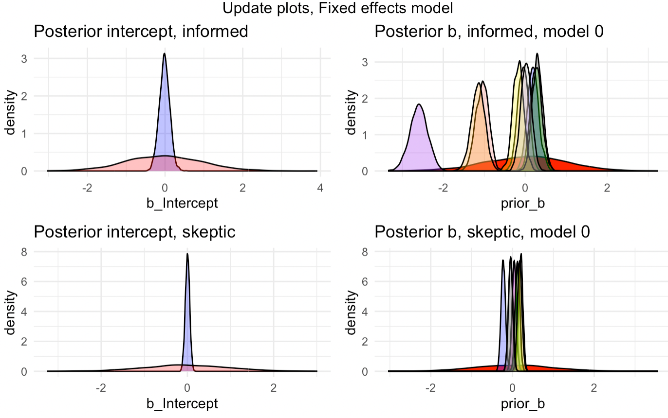

Random intercepts model:

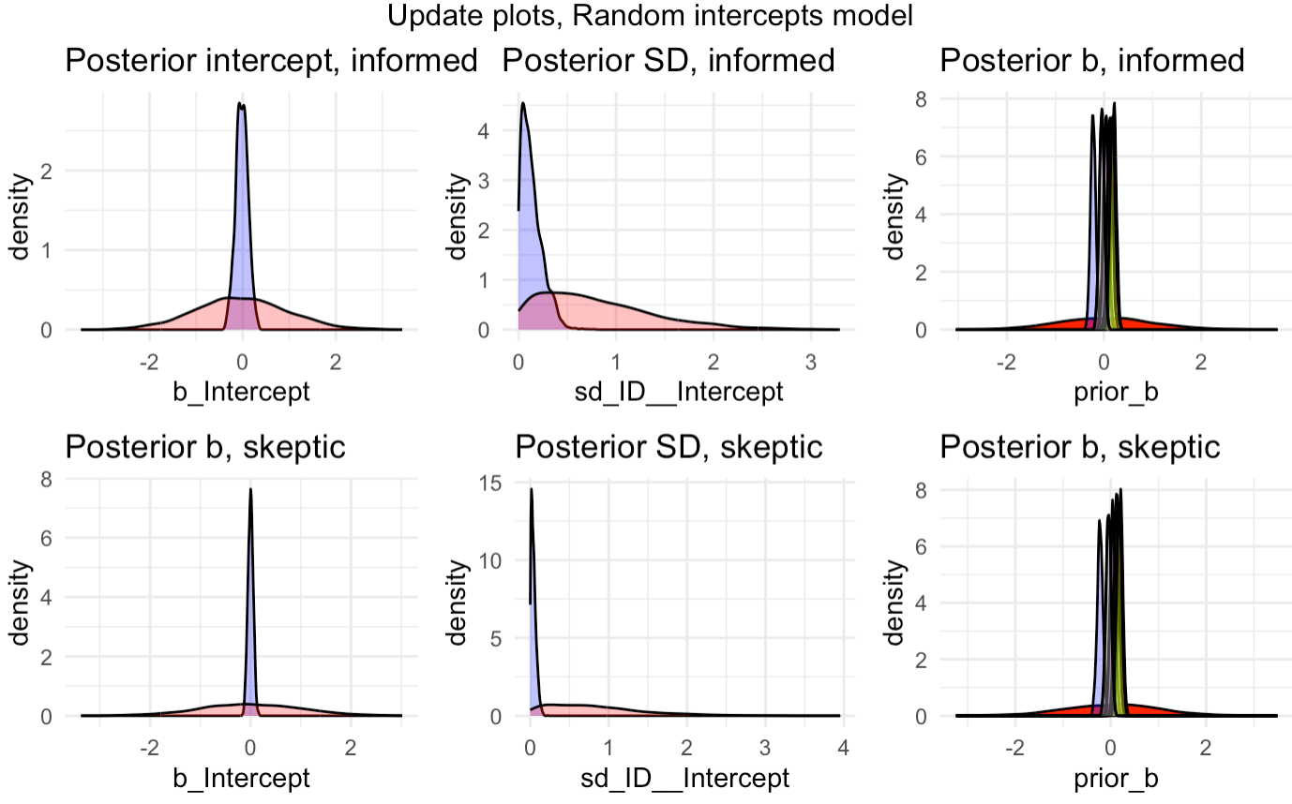

Random slopes model:

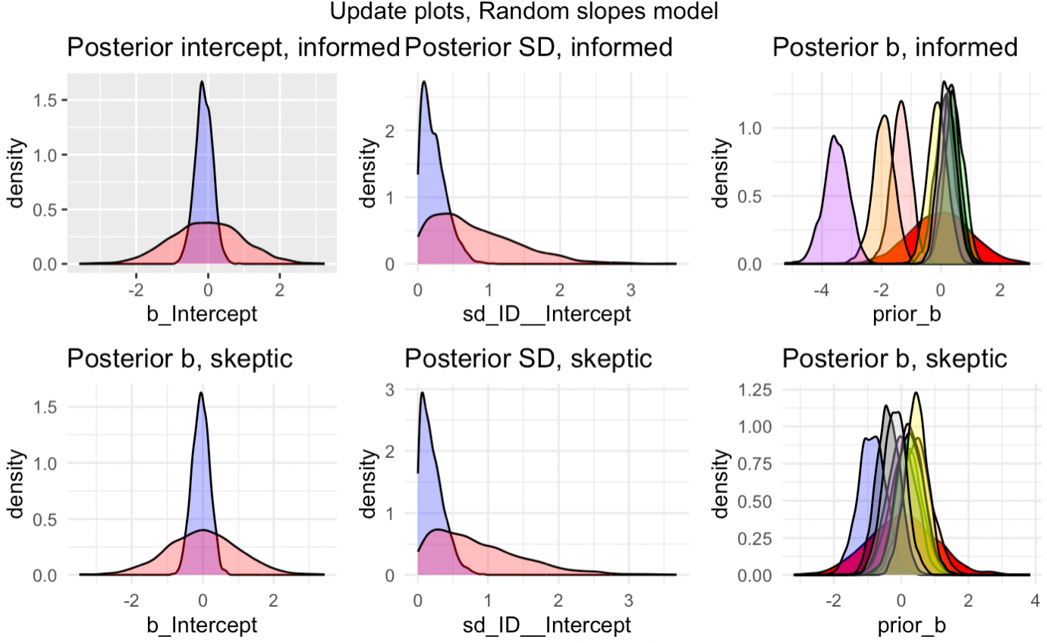

In general, the update plots look alright. But for the informed data for the fixed effects model and the random slopes model we have some variables that pushes a bit towards the tail of the priors. Purple = spoken time – pushes a lot towards the tail. Pitch variance and speech rate is orange and salmon colored – also pushing a bit. This could indicate that the priors perhaps are not loose enough for these specific variables. Especially in the random intercepts model, we see some very narrow distributions for all the update plots that suggest that our posteriors are very convincing especially.

The loo cross-validation however shows a different picture:

|  |  |  |
| --- | --- | --- |
| Model | Elpd_diff | Se_diff |
| Loo_m2 | 0.0 | 0.0 |
| Loo_m0 | -115.1 | 12.2 |
| Loo_m1 | -115.7 | 12.3 |

Weights:

|  |  |
| --- | --- |
| Model | Weight |
| Loo_m0 | 0 |
| Loo_m1 | 0 |
| Loo_m2 | 1 |

These results indicate that the third model which also includes random slopes is the best model.

However, we have to be careful, because we also get the following warning: “Warning: Found 885 observations with a pareto_k > 0.7 in model 'PitchRange_m2'. It is recommended to set 'moment_match = TRUE' in order to perform moment matching for problematic observations.”

A high number of Pareto k values means that the model is overfitting the data, so we might have to discard this model.

A possible overfitting is also apparent when looking at the performances of the models with the varying slopes model reaching 0.9975 with the skeptic data. This is in big contrast to the other models that is just above chance level with the skeptic data. We didn’t expect any signal to exist in the skeptic data, so this result from the Varying slopes model seems rather defective.

Model performance:

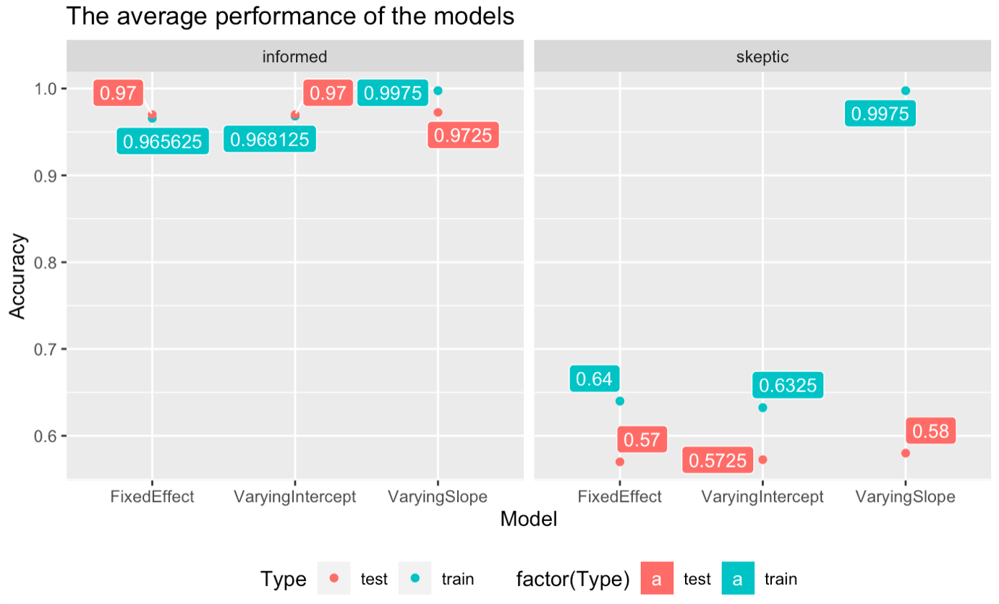

Uncertainty:

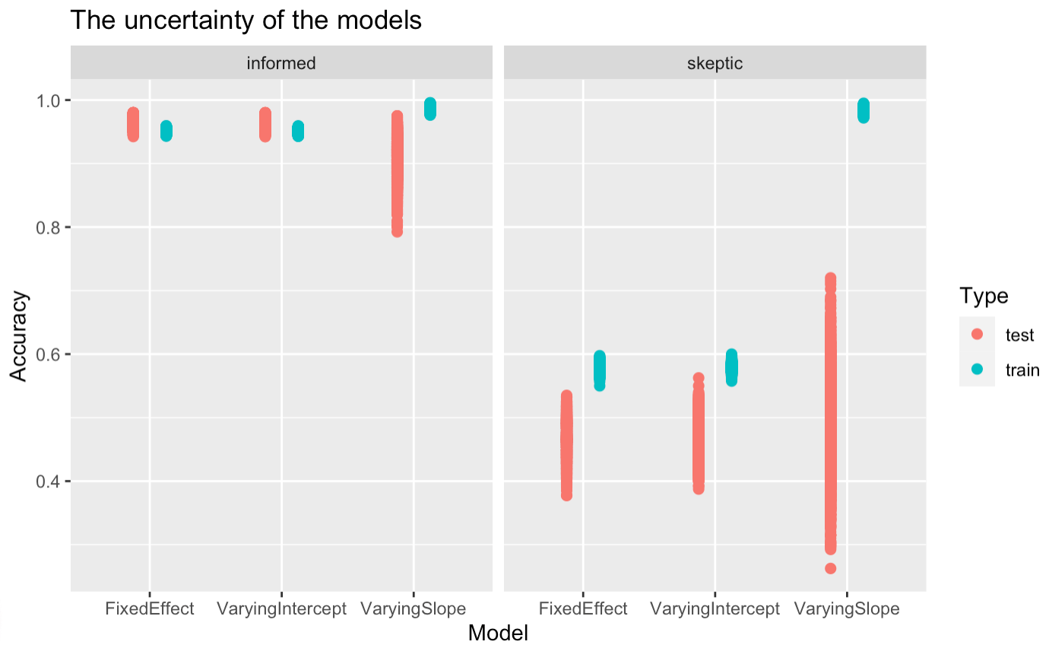

If we disregard the third model the uncertainty looks pretty good for the two other models, with some very confident predictions from the training set and an increased uncertainty on the test set, which is in line with what we would expect.

The performances of the fixed effects model and the varying intercept model is very similar, but the update plots where more convincing for the varying intercepts model and conceptually, it would make much sense that the participants each have a different starting point, so this combined lead me to continue with the varying intercept model on the empirical data.

But first we will look at the importance of each feature for the model:

Feature importance:

Random intercepts model:

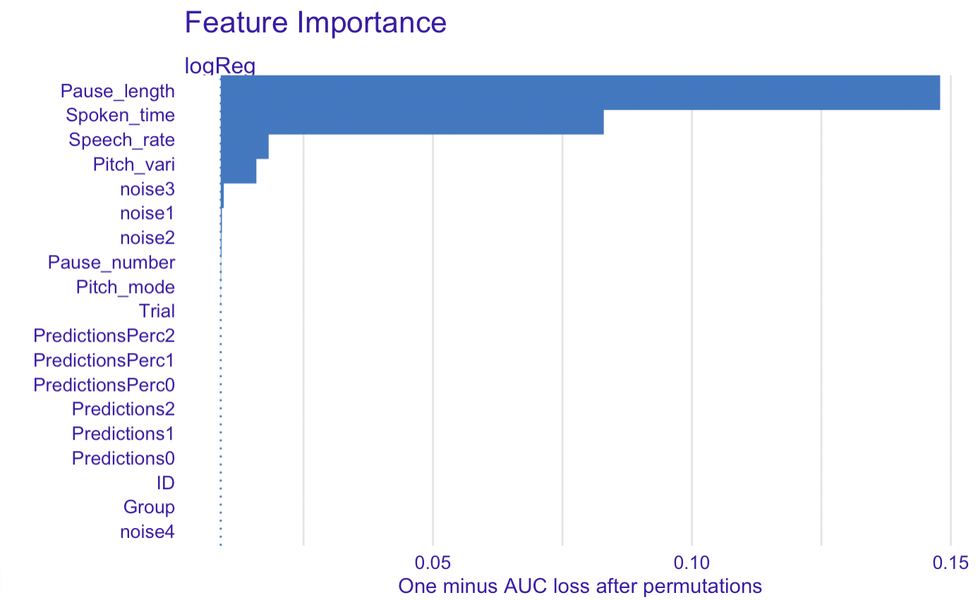

According to our model and the data presented to it, the most important parameters to focus on, when predicting Schizophrenia from acoustic measures is especially the length of one's pauses as well as the amount of time spoken. The participants number of pauses and pitch mode doesn’t appear to be good indicators for schizophrenia or help the model classify whether the participant is in the control or schizophrenia group with the current data, however when applying the model to new data the pattern could look different.

*Part III - Applying the ML pipeline to empirical data*

*Download the empirical dataset from brightspace and apply your ML pipeline to the new data, adjusting where needed. Warning: in the simulated dataset we only had 10 features, now you have many more! Such is the life of the ML practitioner. Consider the impact a higher number of features will have on your ML inference and decide whether you need to cut down the number of features before running the pipeline (or alternatively expand the pipeline to add feature selection).*

The empirical data consists of a 1889 x 398 data frame with information on 10 repeated measures of different acoustic traits of 122 matched pairs of participants with schizophrenia and healthy controls.

With a data frame with this many variables, it doesn’t make sense to include all in our model.

Such a high number of features can have a negative impact on an ML inference by causing overfitting and the model is too closely fit to the training data and does not generalize well to new data. This can cause the model to make inaccurate predictions on unseen data, so it becomes less accurate, it slows down the training and inference time, and it makes interpreting results a lot more difficult. So, we are very interested in scaling down the number of features to be included in our model.

To begin with we exclude all the non-acoustic variables: Language, Gender, Trial, Corpus and PatID. Also many measurements contain both a variable for the mean and median, and there’s no need to keep both of these, so we filter out all the median-variables.

We’re not interested in having features with very strong correlations in our model, so to get an overview of the correlations within our data, we generate a heatmap:

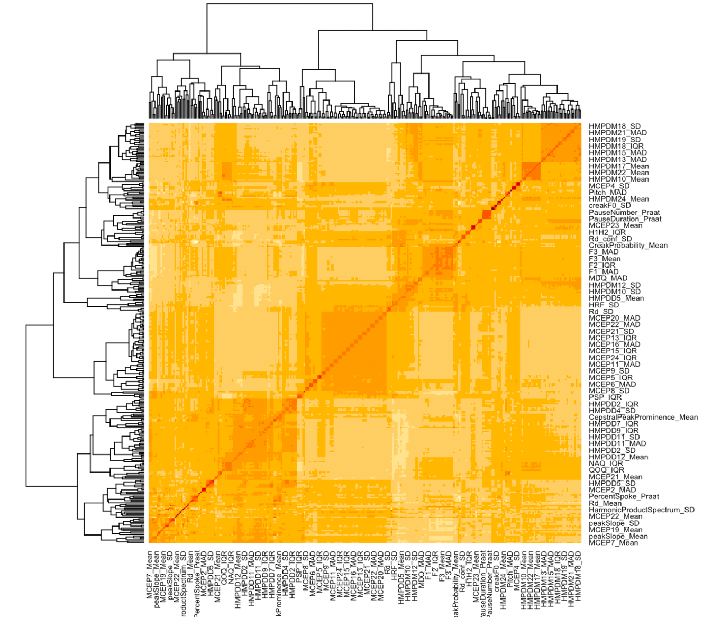

From the heatmap it’s apparent that there are many correlated features in our dataset.

We want to remove all the features that are irrelevant due to a strong correlation with other features (above 0.8), to reduce the complexity of the model. To do this, we create a correlation matrix, which we modify by setting the upper triangular values of the matrix to 0. This is done to eliminate redundant information because the correlation between two variables is the same as the correlation between the same two variables in reverse order. We also set the diagonal values of the matrix to 0 because the correlation between a variable and itself is always 1.

Next, we use the apply function to find any variables with a correlation greater than 0.8. These variables are then removed from the original data frame, creating a new data frame.

This together with the exclusion of the demographic data reduces our variables from 398 to 138.

With our reduced data frame, we follow our machine learning pipeline as previously where we make a balanced training and test set and then scale our predictors.

When we have our scaled training and test set, we expand the pipeline to include feature selection, by assessing the importance of each feature using the Dalex package. Since, we’re gonna run a brms package, we’re Logistic regression in our ranking:

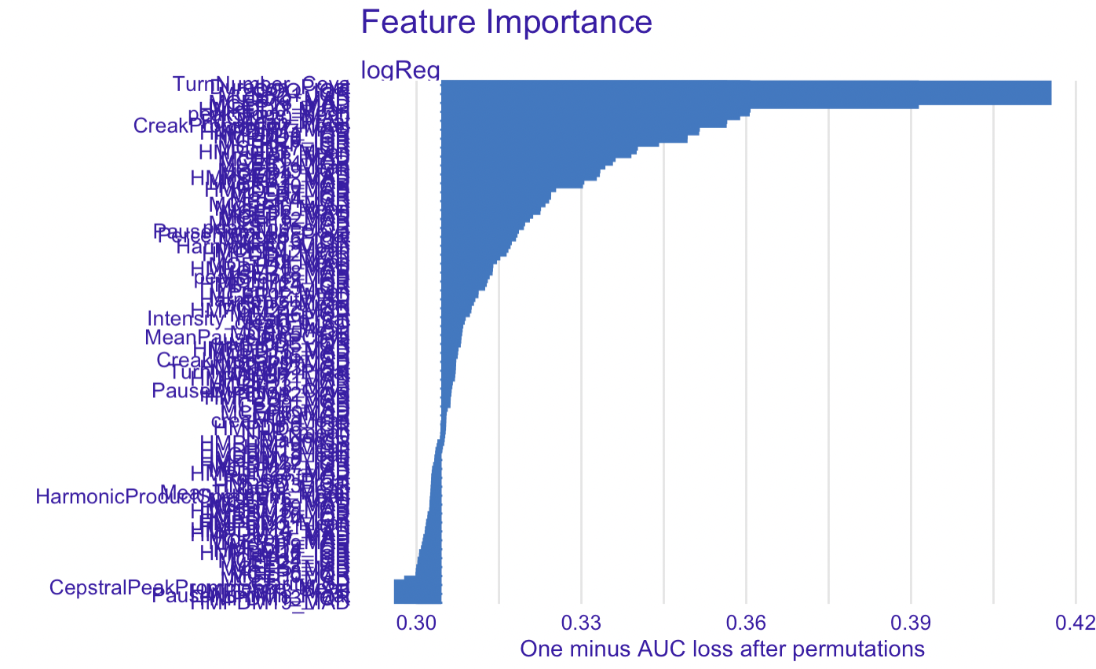

This is pretty hard to interpret, so I zoom in on the top forty most important features:

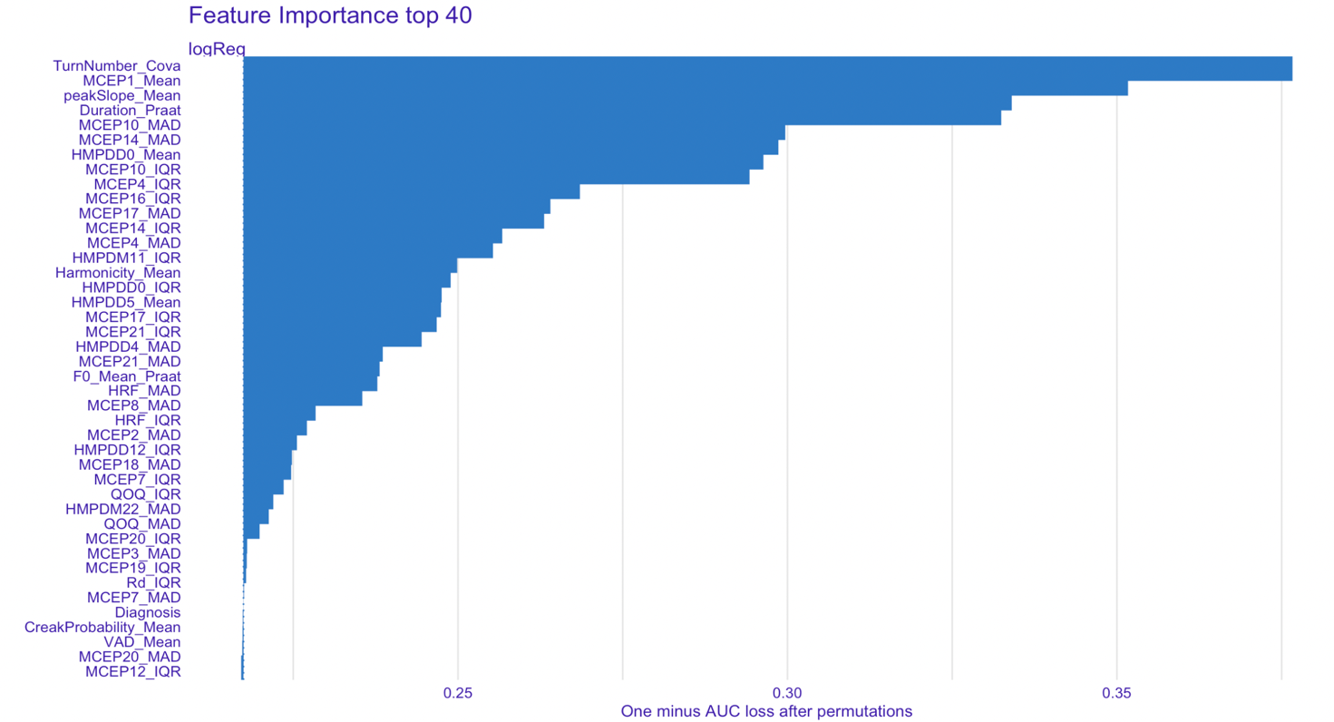

I’m not totally sure, what score can justify excluding / keeping a feature, but I will additionally remove the last 9 variables from MCEP20_IQR and down, since they are somewhat less important than the rest displayed in this plot.

FIXED EFFECT????

Now, we have a remaining of 33 variables that we will include in our random intercept model: *model <- bf(Diagnosis ~ . + (1|NewID))*

*Maybe fixed effects instead!!!*

Prior predictive check:

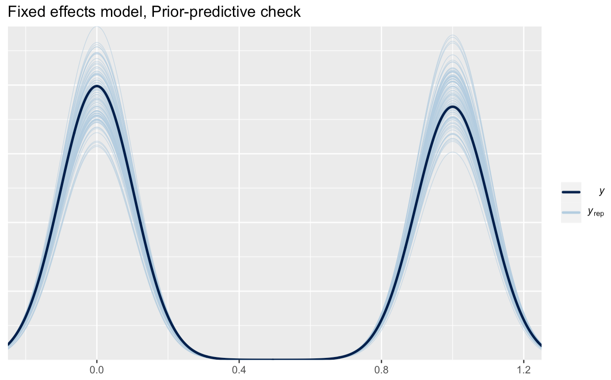

We use the priors from part two and fit the model:

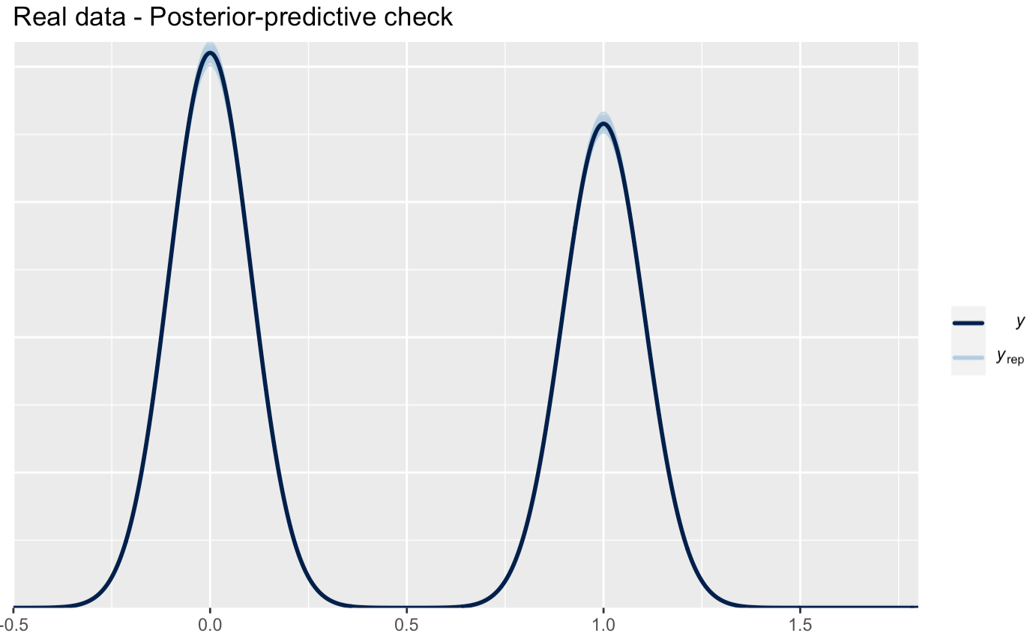

Looks good.

Update plot:

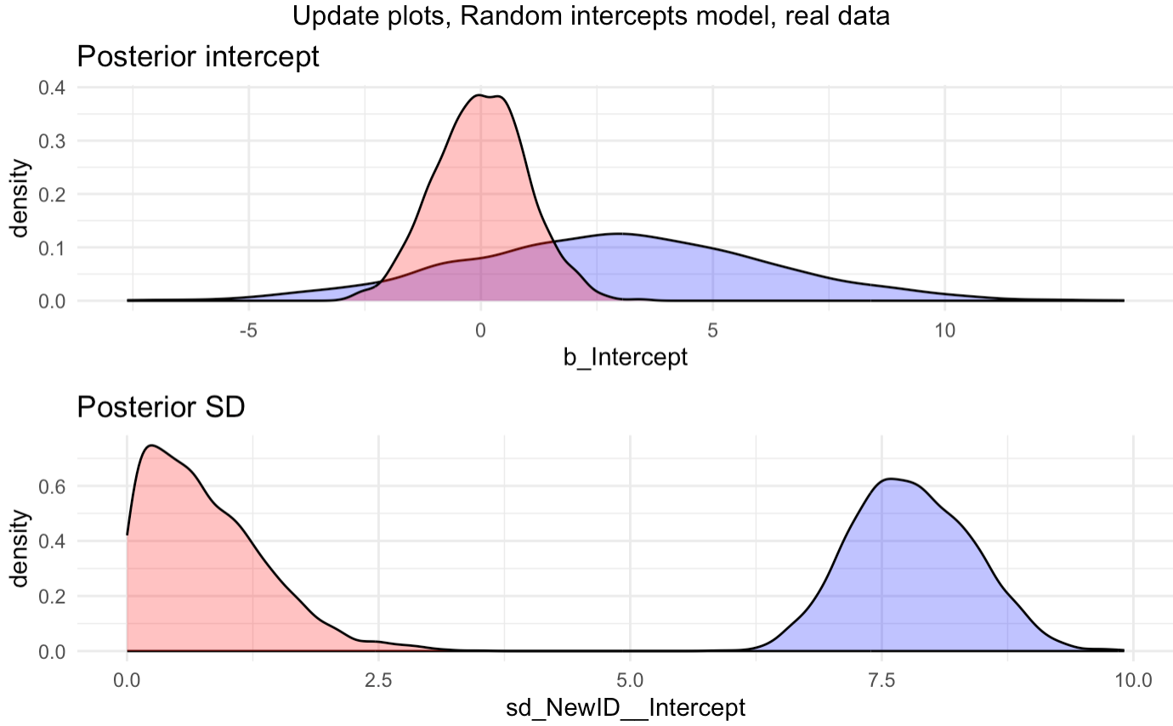

The update plot looks very bad. The posteriors are not captured well by the priors and making loser priors, does not seem to fix the problem. It could seem that we just have a very bad model that is overfitting the training data, which the accuracy scores also indicate:

The model is very confident in its estimates of the training data and around chance for the test data:

|  |  |  |
| --- | --- | --- |
| Test data | | |
|  | Truth |  |
| Prediction | CT | SCZ |
| CT | 181 | 144 |
| SCZ | 23 | 30 |

|  |  |  |
| --- | --- | --- |
| Training data | | |
|  | Truth |  |
| Prediction | CT | SCZ |
| CT | 785 | 0 |
| SCZ | 0 | 726 |

|  |  |  |
| --- | --- | --- |
|  | Train | Test |
| Accuracy | 1 | 0.599 |

Uncertainty of the model:

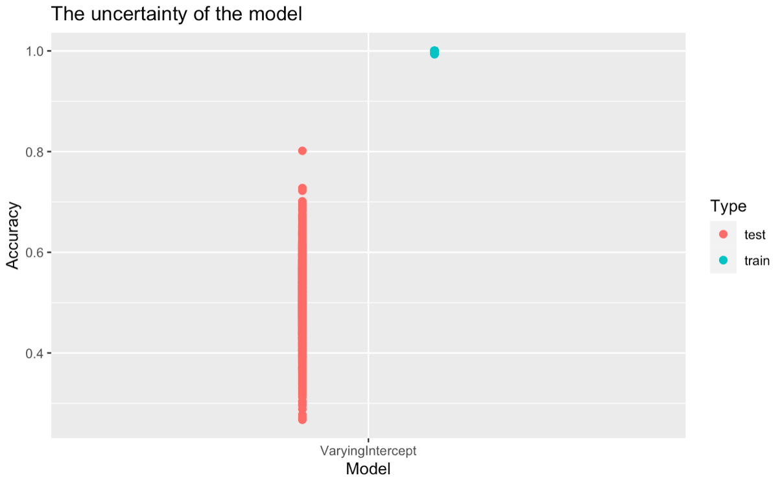

So, the model seems to have overfitted the training data and does not make very good predictions on unseen data, maybe it could make sense to cut down even further on the features or do some dimensionality reduction. I started out by doing factor analysis, but it doesn’t seem to improve the result…